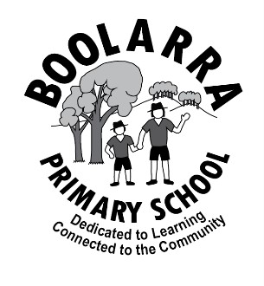
Boolarra Primary School
Parent Information Handbook

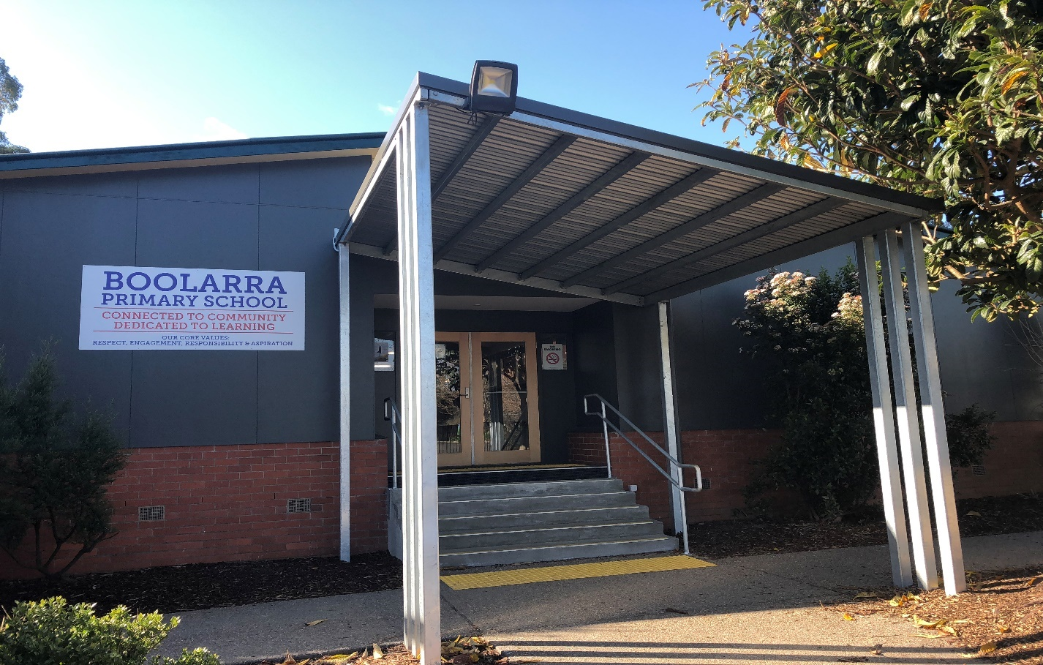

Respect ~ Engagement ~ Responsibility ~ Aspiration

At Boolarra Primary School we value creativity, curiosity, and innovation. We recognise the fundamental importance of reflective and adaptable thinking. Our students are empowered to generate their own course for lifelong learning and make purposeful contributions to their community.

TABLE OF CONTENTS

Principals Message page 2

Contact us and Term Dates page 3

About us page 4
- Agreed Vision
- Our Core Values
- School Context
- Staff Team
- Facilities

Teaching and Learning page 8
- Strategic Plan
- Learning Programs
- Learning Environment
- Student Leadership
- Reporting

Uniform page 12

School Council page 15

Parent Contributions page 15

Communication page 15

Extra Curricula Activities page 16

Behaviour Management and Student Wellbeing page 17

Parent Involvement page 18

Further Information page 19

- School lunches
- Wet day timetable
- Assembly
- Homework
- Blanket permission
- Louis books
- Play/concert
- Library Loans/Borrowing
- Permission to leave school
- Bus travel
- After school arrangements
- Parking
- Bicycle policy
- Student absences
- Emergency management
- Transition program
- School council policies

Foundation (Prep) Student Information page 23

Digital citizenship and cyber-safety resources page 26

Welcome to Boolarra Primary School
Dedicated to Learning
Connected to the Community

Dear Parents,

We welcome you and your child to Boolarra Primary School. At Boolarra Primary School, we value creativity, curiosity, and innovation in our learners. We aim for our students to be confident as learners and to express their individuality through collaborative and respectful relationships. We aim to prepare students to face challenges with a positive and reflective mindset. We believe in our school values of respect, engagement, responsibility, and aspiration and use these to guide our actions and beliefs. We believe that all children are individuals and needed to be treated as such. Teachers need to have the ability to teach at the individual’s point of need, which is why we are committed to small class sizes.

Boolarra Primary School has a strong community feel to it. We are small enough that all students are known by staff and all staff are known to the children. This enables us to be responsive to and engaged with each other. We have a wonderful group of students who are considerate, kind and interact with each other across grade and age levels. We are also very fortunate to have a dedicated and hardworking staff, who aim to ensure that the children in our care receive the best possible learning opportunities. We believe that we are all learners. Through collaboration, staff work together to develop and expand their own professional knowledge and skills in education. We work as a community of educators to plan, deliver, and review lessons, as we aspire to be the best teachers we can be.

We value parent input and provide a range of opportunities for families to be involved in our school community. We encourage parents to assist in classrooms and in extra curricula activities such as sporting competitions and excursions. School Council and the Facilities Sub-Committee provide opportunities for parents who may not be available during school hours.
We believe that your child’s educational journey is a collaborative effort between home and school. We look forward to working with you. Please take the time to discuss any concerns with your child’s teacher. Our teachers are dedicated to your child’s educational journey and bring with them a vast range of experience and knowledge.

Thank you

Susan Duncan
Principal

CONTACTS

Principal Mrs Susan Duncan

Business / Office Manager Mrs Alexandra Boka
(Monday, Wednesday & Friday)

School Council President Any Sparrows

School Address 51 Tarwin Street
P O Box 249
Boolarra, 3870

School Telephone 5169 6471

School Fax Number 5169 6658

E-mail Address boolarra.ps@education.vic.gov.au

School Website www.boolarra.vic.edu.au

School Facebook Page Boolarra PS

2026 TERM DATES

Term 1 Wednesday 28th Jan – Thursday 2nd April

Term 2 Monday 20th April – Friday 26th June

Term 3 Monday 13th July – Friday 18th September

Term 4 Monday 5th October – Friday 18th December

- Foundation students (Preps) do not attend school on Wednesdays throughout February.
2027 TERM DATES

Term 1 Wednesday 27th Jan – Thursday 25th March

Term 2 Monday 12th April – Friday 25th June

Term 3 Monday 12th July – Friday 17th September

Term 4 Monday 4th October – Friday 17th December

- Foundation students (Preps) do not attend school on Wednesdays throughout February.
ABOUT US

OUR AGREED VISION

At Boolarra Primary School, we value creativity, curiosity, and innovation. We recognise the fundamental importance of reflective and adaptable thinking. Our students are empowered to generate their own course for lifelong learning and make purposeful contributions to their community.

OUR CORE VALUES
At Boolarra Primary School, we believe in our school values of respect, engagement, responsibility, and aspiration and use these to guide our actions and beliefs. We have a strong commitment to our school motto, which states “Dedicated to Learning Connected to the Community”. Our core values encourage our learners to be inclusive and collaborate with others.

RESPECT | For ourselves, others, and the environment. Caring for, understanding, accepting, and appreciating ourselves, others, and the environment.
ENGAGEMENT | To be open and interested in learning.
RESPONSIBILITY | Demonstrating ownership of our actions and words. Being accountable for our actions.
ASPIRATION | Demonstrating a willingness to set high goals for ourselves, always do our best, show resilience, and persist when faced with challenges.

SCHOOL CONTEXT
As a small rural school, students, staff, and students have the capacity to build positive relationships with all. We run the Resilience, Rights and Respectful Relationships Program (RR&RR) across all year levels. The main aim of the program is to promote and model respect and positive attitudes and behaviours. This is further enhanced by Zones of Regulation and The Berry Street Model. We value and teach our children the skills to build healthy relationships, resilience, and confidence. We develop student leaders through School Captain and House Captain opportunities. Our student leaders also organise and assist in the running of whole school activities and assemblies.

We value parent input and provide a range of opportunities for families to be involved in our school community. We encourage parents to assist in classrooms and in extra curricula activities such as sporting competitions and excursions. School Council and the Facilities Sub-Committee provide opportunities for parents who may not be available during school hours. We believe that the educational journey is a collaborative effort between home and school.

Our Year Six students are eligible to Attend Mirboo North Secondary College or Kurnai College in Churchill.

2026 BOOLARRA PRIMARY SCHOOL STAFF TEAM


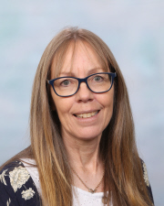






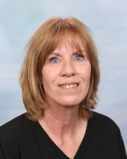



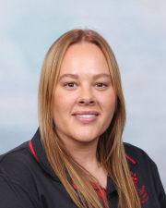
Mrs Cascianelli
Junior Teacher
Mr Kilday
Principal

Mrs Duncan
Principal

Ms Ann Pullbrook
Senior Teacher
Mary Burns
Education Support

Mr Halliwell
Specialist Teacher
MARC Van/Library
Ms Larrad
Specialist Teacher -PE, The Arts, Science
Alexandra Boka
Office Administrator
Jade Henry-Gruis
Education Support
Emily McIndoe
Education Support

Kylie Bentham
Educational Support
Sharon Price
Education Support

FACILITIES

At Boolarra Primary School, we are spoilt for space and our children are fortunate to be able to play and learn in such a picturesque setting.

Buildings & Playgrounds
We have spacious classrooms and excellent facilities. Our outside areas include:
- Oval
- Basketball court
- Cricket nets
- Expansive grassed area
- A variety undercover spaces for quiet activities.
- Playground facilities.
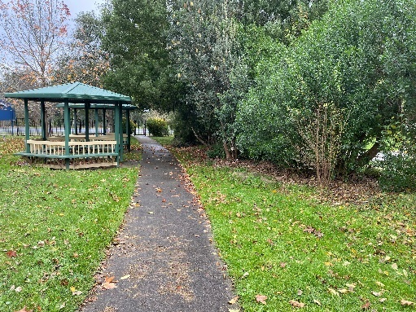
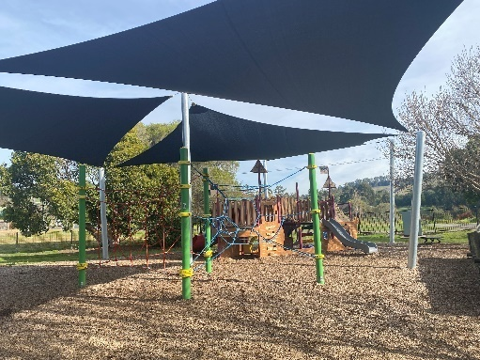
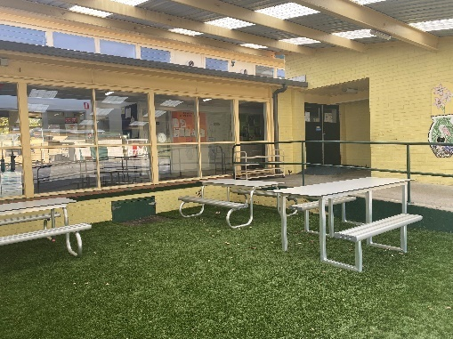
- Many shaded areas.

Life Skills Kitchen
The Life Skills Kitchen is a fully equipped kitchen with ovens, stove-tops, fridges, sinks, island benches and plentiful storage. We use this space to store and supply the breakfast and snack provisions provided by Foodbank Victoria as part of the Schools Breakfast Club program which is run on a Wednesday morning, and for whole class cooking/science activities.
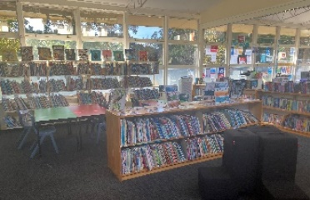
Library/Marc Van
Our library is well resourced, with a range of fiction, non-fiction, and picture storybooks. Mr Halliwell runs library session with students on a weekly basis to promote borrowing for home reading and enjoyment visiting once per week.

Art/Science Room
Our Art/Science room is a dedicated, well-resourced space for Art and Science lessons. These are each conducted on a weekly basis by Ms Larrad.

Multi-purpose Room
We have a large Multi-purpose Room that is used for whole school gatherings, such as assemblies, concerts and visiting speakers. This space is also used for our indoor sports and wet weather activities.

Computers
Boolarra Primary has shared sets of Notebook computers and iPads. Computers are located in the breakout space of the Learning Teacher Centre (LTC) for our middle and senior students. IPads are kept within the classroom.

BELL TIMES

Students are permitted to enter the school building from 8:35am to hang up their bags etc. to get ready for the school day. From 8:30am until classes commence each day, and during all outside breaks, a teacher is on yard supervision. Music is played before each ‘come in’ bell to provide students with time to get to their designated line up spot.

8:35 – 8:45 Bag bell so students can enter classrooms put bags in and get ready for learning.
8:45 – 10:30 1st Learning Block
10:30 – 10:40 Supervised eating of snacks in classrooms
10:40 – 11:00 Morning Recess ‘Play’ Break
11:00 – 1:00 2nd Learning Block
1:00 – 1:10 Supervised eating of lunch in classrooms
1:10 – 2:00 Lunch ‘Play’ Break
2:00 – 2:15 Whole School Silent reading
2:15 – 3:15 3rd Learning Block
3:15 Home Time

Please ensure that students are at school before 8:45 am. It is important that students can be involved in morning routines and socialise with their classmates.

SCHOOL CLOSURE / PUPIL FREE DAYS:
Schools are allocated five pupil-free days a year, during which teachers can undertake special training and development programs. These will be advertised in advance through the school newsletter, uEducateUs and the school’s website.

TEACHING AND LEARNING

STRATEGIC PLAN:
Back in 2023, we developed our 4 year Strategic Plan. The plan outlines our overarching direction for the next four years and maps out how we are going to provide the best learning and development experience for our students. A copy is available at the front office and on our school website.

Our 2023 – 2027 goals are:
- Improve student learning outcomes in literacy and numeracy.
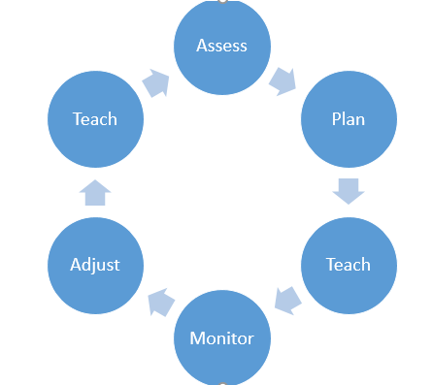
- Establish processes to build teaching knowledge and practice around the school’s instructional model, practices, and engagement norms.

LEARNING PROGRAMS:
A broad and balanced educational program is provided and is based on the Victorian Curriculum 2.0 and the Victorian Teaching and Learning Model 2.0. We use a teaching cycle to ensure our instruction is at the point of need of our students.

🎯 What Is the VTLM 2.0?
The Victorian Teaching and Learning Model 2.0 helps teachers plan, teach and assess learning in a clear and consistent way.
It ensures every child receives high-quality teaching and makes strong progress.
🔄 The Learning Cycle
Teachers use a structured cycle to support student growth:
- Assess – Understand what students already know
- Plan – Design learning that meets their needs
- Teach – Use proven teaching strategies
- Check – Monitor progress and understanding
- Adjust – Provide feedback and tailor next steps

💡 High-Impact Teaching Strategies (HITS)
Teachers use approaches that research shows work best:
- ✔️ Explicit teaching
- ✔️ Goal setting
- ✔️ Feedback
- ✔️ Questioning
- ✔️ Differentiation (supporting every child at their level)

🌱 Practice Principles
These core principles guide learning across the school:
- High expectations for all students
- Safe, supportive learning environments
- Respect for each learner’s background
- Collaboration and strong relationships

🗣️ Student Voice & Agency
Students are active partners in their learning.
They are encouraged to:
- Set goals
- Reflect on progress
- Make choices
- Share ideas and ask questions
This builds confidence, independence and ownership of learning.
👧 What This Means for Your Child
Your child will experience:
- Clear learning goals
- Regular feedback
- Lessons designed to meet their needs
- A positive, engaging classroom
- Support to grow as a confident, capable learner

👪 What This Means for Families
You’ll see:
- Learning goals and success criteria
- Updates on how your child is progressing
- Opportunities to partner with teachers
- A focus on celebrating growth and effort

English
Our literacy program provides students with opportunities to develop their reading, writing, and speaking and is underpinned by specific skills.

- Phonics
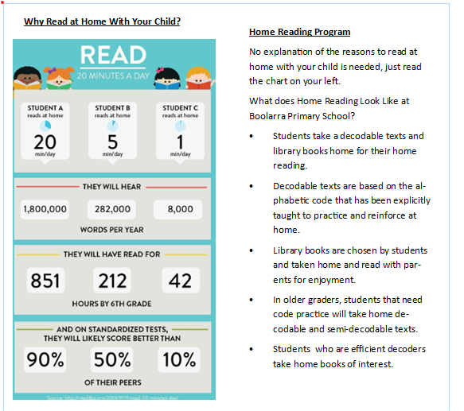
An ability to hear, identify and manipulate single sounds. Teachers have undertaken Sounds Write Training to enable them to deliver a high quality, evidence-based literacy program that explicitly teaches the skills needed to be effective readers and writers.
- Morphology
Words are made up of parts that have meaning (morphemes). Explicit teaching of these word parts and their meanings
- Fluency
Reading with speed, phrasing, and accuracy.
Having a store of known words for reading and writing.
- Vocabulary
Understanding the meaning of a wide variety of words.
Using a variety of words to enhance our message.
- Comprehension
Understanding the meaning of what is read.
- Grammar and Punctuation
Understanding that punctuation and grammar enhances meaning.
- Text Structure
Understanding that to communicate effectively we use different organisational features.
Numeracy
Our numeracy program aims to help students develop increasingly sophisticated and refined mathematical understanding, fluency, reasoning, and problem-solving skills. These proficiencies enable students to respond to familiar and unfamiliar situations by employing mathematical strategies to make informed decisions and solve problems efficiently.

- Understanding
Students describe their thinking and comprehend the information. They can represent their thoughts and make connections. They make comparisons.
- Fluency
Students develop skills to readily recall factual knowledge and choose appropriate procedures. Students use strategies that are flexible, efficient, and accurate.
- Problem Solving
Students make choices, interpret, formulate, model, and investigate problem situations. They select and use technological functions and communicate solutions effectively.
- Reasoning
Students explain their thinking and justify their strategies. They make comparisons and transfer their knowledge from one context to another.

SPECIALIST PROGRAMS

Specialist Programs in 2026 have operated as follows:
- Physical Education
- The Arts
- Science
- Marc Van - Literature

Supporting Programs:
- Literacy and Numeracy Support
- Social Skills Program
- Berry Street Education Model
- Respectful Relationships

LEARNING ENVIRONMENT

Emphasis is placed on providing a positive learning experience for our students by:
- Maintaining an environment that is safe, friendly, and supportive
- Encouraging children to be resilient and to embrace and work through challenges
- Extending students through providing opportunities to enhance their individual talents
- Aiming to develop students who are socially responsible, independent, and self-disciplined
- A strong commitment to addressing the individual needs of students.

Explicit Teaching Model
At Boolarra Primary School, we use the Explicit Teaching model to support every child’s learning. This approach means teachers clearly explain and demonstrate what students need to learn, using step-by-step examples. Students are then guided through practice with plenty of feedback to help them succeed. Learning is broken into small, manageable parts, with support gradually reduced as students become more confident and independent. We also connect new learning to what students already know, helping them build strong foundations, strengthen long-term memory, and avoid feeling overloaded.

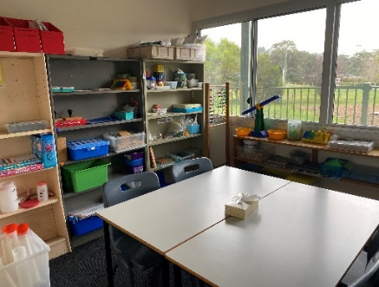
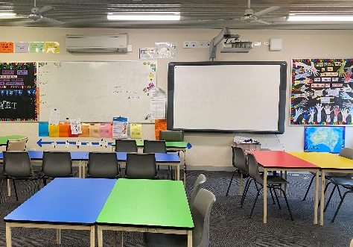
Student Collaboration
At Boolarra Primary School, we believe students learn best when they have opportunities to share and discuss their ideas with others. As part of our Explicit Teaching Model, we build in structured moments for collaboration so that students can talk through their thinking, deepen their understanding, and learn from different perspectives. One way we do this is through the Engagement Norm of ‘Think/Pair/Share’, where students regularly turn to a partner to explain their ideas or respond to a question. This routine helps every child practise verbalising their learning, listen actively to others, and stay engaged throughout lessons.
Learning Tutor
Small group sessions are conducted by our Education Support staff and/or a tutor teacher in the areas of literacy and numeracy. We provide intensive learning opportunities so targeted students can keep up or catch up with the class.
Interactive Technology
Every classroom has an interactive whiteboard. Using online games and videos we can teach students in different ways. We believe that no two students are the same so learning needs to be individually tailored.
STUDENT LEADERSHIP

Boolarra Primary School values student voice and provides opportunities for our students to fully participate in school life. We aim to develop the attitudes and behaviours in our students that promote student voice, agency, and leadership. Our student leadership team meets regularly to discuss ideas and make plans to improve our school.

SCHOOL CAPTAINS:
School Captains are chosen at the end of the year in readiness for the new year. Students write an application and go through an interview process that is run by students and teachers. School Captains are given opportunities over the year to develop their leadership and organisational skills. Our School Captains run our assembly each Friday afternoon.

Did you know our students are actively involved in the decision-making processes? Our senior students choose the colour of our new table tops and furniture aiming to make our school bright and cheery. The colours also reflect our schoolhouses, and our green learning table is our colour to represent “Ready for Learning’.

HOUSE CAPTAINS:
House Captains are chosen at the end of the year in readiness for the new year. Students write an application and go through an interview process run by students and teachers. House Captains are given opportunities over the year to develop their leadership and organisational skills by running House Competitions.

JUNIOR SCHOOL COUNCIL:
The Junior School Council (JSC) comprises students elected from grades 3-6 (with grade 5 & 6 students chosen to represent the Prep / Ones). This group meets regularly and organises fundraising efforts for worthy causes. They also discuss issues raised by the student body and make recommendations, which are passed on to the School Council.

Our student leaders regularly run whole school activities. We believe that leaders learn by doing.

Our leaders organise club activities for the whole school. We finish the week by working in mixed age groups and engaging in fun activities such as gardening, cooking, art, and sport.
When cooking we try to use ingredients from our vegie garden.
REPORTING

- Foundation (Prep) parents will have an individual meeting with their child’s classroom teacher early in the school year to ensure we all have the information required to ensure a smooth start to school life.
- Term 1 - Student Led reporting
- Term 2 - Written Academic Reports
- Term 3 - Student Led Reporting
- Term 4 - Written Academic Reports.
Parents are welcome to make appointments to meet with teachers to discuss their child’s progress at any time that is mutually convenient. We believe that a child’s educational journey should be a shared responsibility between home and school.
UNIFORM

All students are required to wear our school colours of red and navy blue. There are many combinations possible but, we recommend a blue windcheater and matching track pants for winter and a red or blue polo top with blue shorts for summer. The red and white, or blue and white checked school dresses that can be purchased from places like Target and Big W are also acceptable.

- Navy Blue or red polo shirt (with logo optional) – short or long sleeve
- Navy Blue shorts/tracksuit pants
- Navy Blue or red polo fleece windcheater / hoody / cardigan.
- Red/White or Navy Blue/White checked dresses.
- Navy Blue Skorts
- Navy Tunic
- School shoes, runners or flat boots. (no open toed shoes, or shoes that slip off easily)
- Broad brimmed hat/legionnaire style

Red and blue sports tops and school jackets with our logo on them are available for our students to borrow and wear when they represent us at various endeavours. Both wash and wear well, allowing them to be passed on to younger siblings as they still look bright and fresh after many years of wear. We source these locally (from Logo Express in Traralgon) and keep a small quantity in stock at the office that are available for purchase. See Alex in the office or the principal to have your child try on tops to establish the correct size and order what is required.

All clothing should be clearly labelled with the owner’s name. The children should be dressed appropriately for the weather conditions. Thongs, open toed shoes, dresses with thin shoulder straps, singlets and tank tops should not be worn at school. As we are a Sun Smart school, children must wear broad brimmed hats when they are outside during term 1 and 4. If they do not have a suitable hat, they must remain in a shaded area. Students are to always wear school uniform each day, except on designated ‘out of uniform days’ which are staged once a term by our Junior School Council to raise money for worthy causes.

Please refer to our:
- Uniform Policy
- SunSmart Policy
Polo Tops and Jackets with school logo can be purchased from the office.
- Polo shirts - $25.00 Adult size $30.00
- Jackets - $52.50 & adult size $57.00
SCHOOL COUNCIL

Our School Council are the elected representatives that approve the policy and programs implemented at our school and ensure that the funds provided by the parents and the Education Department are correctly utilised. This group comprises of elected parents and staff. We try to make our meetings as efficient and friendly as possible. Information for parent school councillors is sent home via e-mail on the Friday before the meeting. Our School Council meets on the last Wednesday of each month. Meetings begin at 5.00pm. We encourage parents to stand for election, as being a school councillor is a very positive way to be involved in our school. Elections to fill vacant positions are held during February / March. School Councillors are elected for a 2-year period. School Council information is included in our fortnightly newsletter and displayed on the noticeboard near the office.
PARENT CONTRIBUTIONS

The Government provides the school with funding to enable each child to obtain an education. The funds provided by the Department do not cover the cost of enrichment programs and other educational materials. Under the Education Department rules, schools can request a contribution from parents/carers to cover the cost of books, stationery, classroom consumables, Mathletics subscription and the student insurance policy that covers all our students against accident and injury.

Our Parent Payment Contribution
Contributions can be made each year by families. It is reviewed annually by School Council. School Council aims to keep contributions as low as possible. In 2025 the contribution was $150.00

Parents can pay by direct deposit. You can do this through the Commonwealth Bank BSB 06 3522 Account No. 10068539; use your child/ren’s surname as reference. If you would like to set up a progressive payment scheme, please see Alex, the School’s Business Manager to put this in place.

COMMUNICATION

It is vital that we maintain good communication between the school and the home to ensure that we are achieving the best possible outcomes for our children.

We communicate through the following:
- Fortnightly newsletter published on uEducateUs on Fridays
- Announcements via uEducateUs
- Boolarra Primary School Website
- Boolarra Primary School Facebook (for families of children at Boolarra Primary School).
- Notes are given to students and are available on uEducateUs
- Changeable sign at the front of the school.

EXTRA CURRICULA ACTIVITIES

We actively seek and utilise additional experiences to enrich our learning program. We seek extra curricula activities that build on the learning experiences offered at school. These may include excursions such as a visit to Healesville Zoo or Scienceworks or incursions such as visiting shows and webinars.

EXCURSIONS:
Excursions are designed to broaden the children's experience, as well as building on the class themes. Transport costs are high, and for this reason we endeavour to give as much advance notice as possible. Parent assistance may be requested to help with transport.

CAMPS:
Our 3-6 Students have the opportunity to attend camp each year in various camp locations to ensure that each camp experience is different throughout their time at Boolarra Primary school. Our current Outdoor Education / Camping Program allows the children in P/1/2 to have a dinner at school in term 4.

Parents are welcome to take advantage of a progressive payment scheme to cover the camp costs if this assists with budgeting. This can easily be set up with our Business Manager, Mrs. Alexandra Boka.

SOMERS CAMP
Every second year, Grade 5 and 6 students at Boolarra Primary School have the opportunity to participate in the Somers Camp Program, a unique nine-day residential experience run by the Victorian Department of Education. Somers Camp brings together 160 students from different schools across Victoria, giving children the chance to build friendships, develop independence, and learn in an outdoor environment. The camp is staffed by highly qualified teachers who are passionate about outdoor education, along with visiting teachers from schools across the state. As places are limited, each school is allocated a set number of positions, and a ballot system is used to ensure fairness in the selection process.

SCHOOL SPORTS:
We hold our own athletic school sports in term 1. All children participate and represent their House; the emphasis is on skill building and enjoyment. Children are assigned a House group when they enrol. Our Houses are MorrowLuna {Red and Green] and StrezIrving [Yellow and Blue]. These sport houses were renamed in 2022 by combining past Sport House names (Irving, Green – Penaluna, and Yellow – Strzelecki) Senior students are elected as House Captains.

RECESS AND LUNCH ACTIVITIES:
- Children may borrow sports equipment from the Sports Shed at both recess and lunch
- Library regularly opens at recess for quiet activities
- A variety of activities such as chess, draughts, table tennis, crafts, colouring, board games building blocks are placed out in the undercover area each recess and lunchtime for students to access.
- Use of swing
We involve our students in the organisation of activities, so these change over the course of the year.

s

BEHAVIOUR MANAGEMENT & STUDENT WELLBEING

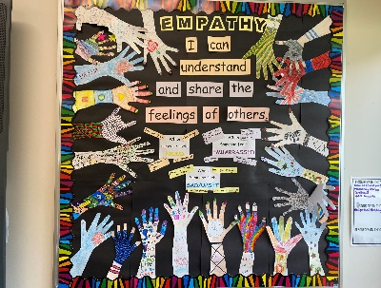
At Boolarra Primary School, we actively support our students in developing strong and respectful social skills that help them build positive relationships and contribute to a caring school community. Through explicit teaching and coaching, students learn strategies such as using positive self-talk, communicating effectively to resolve problems, welcoming and including others in play, and taking action rather than being a bystander when conflict arises. These important skills are taught and reinforced through our Respectful Relationships, Berry Street Education Model, and Zones of Regulation programs. As a smaller school, we value the strong connections we build with one another, enabling us to work closely together and provide consistent support for every child’s growth and wellbeing.

Students undertake specific learning of Personal Development Curriculum for at least 1 hour per week. Classes are given frequent short brain break activities so students can recentre and be ready to learn. We believe that predictable routines lead to positive behaviour. To achieve this every class begins with Morning Circle. Timetables and changes to the day are discussed, children greet each other warmly and time is given to creating a positive start to the day. By building strategies into everyday structures our school environment is a calm and positive place to learn.
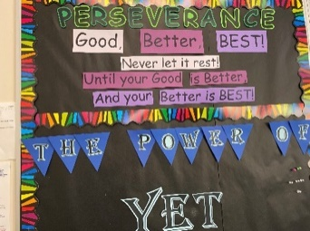
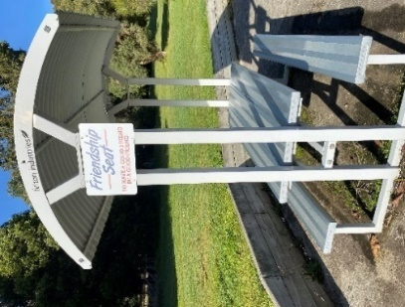
Classroom teachers place a strong emphasis on positive recognition for appropriate behaviour. This is celebrated through our Student of the Week announced at assembly every Friday afternoon. Students can also win points for their House. These accumulate over the month and, at the end of the month, the House with the most points receives a reward [such as hot chips for lunch]. We also present raffle tickets to students who show positive behaviours outside in the yard during recess and lunch play. Raffle winners are drawn at Friday assemblies and can choose a prize from the prize basket.

A friendship seat has been set up in the central play area near the basketball court. The purpose of this seat is to provide a place where students can sit if they are lonely or sad, in doing so alerting teachers and other pupils that there might be a problem.
VOLUNTEER INVOLVEMENT

Parents/Carers are an important part of the school community. There are numerous opportunities for parents to support school staff and students whether through volunteering in the classroom or helping to with sports days, in the library and or with other programs such as Swimming.

We value parent input and aim to provide opportunities for students to connect with our community. When parents are actively involved in school life, they are clearly demonstrating that they value their child’s education; this is also a great way to find out firsthand what is happening at school. All volunteers are required to have a Working with Children’s Check

PARENTAL CONTACT:
We firmly believe that schools need to work in partnership with families to achieve the best outcomes for our students. Teachers have a responsibility to communicate any concerns, as do parents. If you ever have any concerns or issues about any aspect of school life, please do not hesitate to raise the matter with your child’s classroom teacher, relevant specialist teacher or myself.

In instances where the student’s parents are separated or divorced the school will provide equal access and information to both parents unless Family Law Court Orders stipulate otherwise. The school should be provided with a copy of any relevant Family Law Court orders upon enrolment. In the event of custodial disputes, the principal will be guided by the Education Department’s Legal Department to ensure the students’ safety, wellbeing and needs are met.

If you are volunteering, please sign the Volunteers & Visitors Sign In and Out Book located at the front of the office. Please take a Visitor or Volunteer Lanyard so staff are aware that you are volunteering/visiting. These measures help to keep our student community safe.

FURTHER INFORMATION

EXTREME WEATHER DAYS
On extreme weather days (hot, wet, high winds, smoky) children remain inside during our recess and lunch breaks with teacher supervision. Students have the opportunity to play quiet games, draw, read or talk with friends.

ASSEMBLY:
General assemblies are held each Friday afternoon, commencing at 2:45pm. The School Captains conduct the assembly which is held in the Learning-Teaching Centre (LTC). The acknowledgment is recited, national anthem sung, the week’s special events shared, birthdays acknowledged, announcements made, and awards presented. Parents are most welcome to attend assemblies.

HOMEWORK:
We have the expectation that all children will read for a short time every night. Students in all classes are provided with books from the classroom or school library. Students are also encouraged to practise their maths as we take out Mathletics Membership for all our students. This online Maths program is a great way to build maths skills at home. Passwords are sent home with students.

BLANKET PERMISSION:
Blanket permission is sought from parents at the start of the school year to cover outings in the immediate vicinity of the school.

On the Blanket Permission Form, we also seek parent permission to publish children’s photos in the newsletter and in the local papers. This same Blanket Permission Form should be used to advise us of any medical conditions your child may suffer from or any medication requirements. It is especially crucial that we have an up-to-date Asthma and/or Anaphylaxis Plan for any asthmatic or anaphylactic students. It is very important that the Blanket Permission Forms are filled in and returned to school at the start of the school year. If medical conditions change throughout the year please inform the school so medical forms can be updated.

LOUIS SCHERER BOOKS:
Louis Scherer was a former student who died of leukaemia in 1998, just after he graduated from our school. Our Library houses some books donated by Louis’ family to the school. From time to time your child might borrow one of Louis’ books – you will know if this occurs as they have a special sticker attached on the inside cover.

PRODUCTION/CONCERT:
On alternate years, we have either a major musical production or a school concert. In 2025, our school produced Boolarra Rocks.

LIBRARY LOANS/BORROWING:
All children can borrow books from our Library and are asked to return them after 2 weeks. Sometimes library books do not make it home so if your child is reporting that they have a book out in their name that you have not seen, check with the classroom teacher as it might be in their locker or somewhere in their classroom.

PERMISSION TO LEAVE SCHOOL:
Children will not be permitted to leave the school ground unless they have parental permission and are picked up by an adult. If children are collected from school during school time, this must be registered in the sign out book at the office. This book is used along with the classroom rolls in the event of an emergency evacuation to check all children’s whereabouts.

BUS TRAVEL:
Mirboo North Secondary College coordinate the school buses that service our school (Budgeree, Grand Ridge and Boolarra South). To qualify to travel at no cost, students must live a prescribed distance from the school and must be attending the nearest government school. In some instances, students may be granted a place on the bus if they live closer to the school, but this will only be if seats are available and Mirboo North Secondary College approves this. Forms to apply for regular bus travel are available from our office.
Bus Supervisor, Dianne Sharman oversees the bus travellers as they arrive in the morning. One of our teachers takes responsibility for supervising the bus travellers after school. If students are not travelling on the bus, parents need to either advise us of this in person, write a note or contact the school outlining whom they are authorised to go home with. This is particularly important as often students tell us they are going to someone’s house, but we do not know if this is what their parents have agreed to. Occasional travellers are permitted to travel on the buses to visit a friend if a written note is submitted to our school so the principal can provide the necessary authorisation to the relevant bus driver.

AFTER SCHOOL ARRANGEMENTS
Upon dismissal, our students are in the care of their parents, or the person authorised by their parent to collect them. Students who are instructed by their parents to walk home are required to do so as soon as possible. If parents wish to remain within the school grounds so their children can play on the school equipment, parents need to ensure they still adhere to the school rules and take full responsibility for their child’s behaviour and safety.

The school staff keep a watch on who is collecting students at the end of the day, particularly the younger ones. Please let us know if someone we are not accustomed to seeing, is authorised to collect your children to avoid potentially awkward situations.
If parents or carers are ever delayed, please contact the school so we can arrange for the impacted children to be supervised by the Bus Duty teacher.

CAR PARK – PARKING:
The Education Department has provided the car park for staff and disabled parking only. The turning loop is for the buses to use but may be used by parents as a quick drop-off and pick up point. Please do not use the drop-off/pick up zone to park. Children are not permitted in the car park at any other time unless they are in close physical contact (holding hands preferably) with an adult. Parking for parents outside the school is limited and during peak period times (home time) it can get very congested and dangerous. Please take great care. School Council recommend that large vehicles (such as 4-wheel drives) park on the opposite side of the road as these can obscure vision. Please note that the 40km speed limit applies outside our school during morning drop off and afternoon pick up times and this is enforced by the police.

BICYCLE POLICY:
School Council is not responsible for children riding to and from school, but wish to encourage children who do ride, to do so in a safe manner. If parents allow their child to ride to and from school, they, and the child, are accepting responsibility for their behaviour. As identified by the Road Traffic Authority, children in Years Foundation to 3 are too young and inexperienced to ride bicycles to school without adult supervision. In line with sound safety practices, children in this age group should not ride their bicycles to school unless accompanied by an adult.

It is a requirement by law, that children wear helmets when riding their bikes. The school provides a storage area for bikes, but it should be noted that it takes no financial responsibility for theft or damage to bikes brought to school.

Students must walk with their bikes inside the school grounds. No scooting on bikes or riding bikes, scooters or skateboards within the school grounds is permitted.

STUDENT ABSENCES
School attendance is a legal requirement. The Education Department has an “Everyday Counts” policy; this promotes the importance of regular attendance to ensure strong learning. If students are absent from school parents need to inform the school. This can be done by:
- Submitting an absence notification on uEducateUs
- Contacting the school

If home has not contacted the school, school will ring on the first day of absence. If families know that they will be away for an extended period, please see the classroom teachers so learning tasks can be set to minimise the disruption to our students’ learning and notify the school via uEducateUs or contacting the school.

Late Arrival
Arriving at school on time each day is important for all children. Being punctual helps students start the day calmly, prepares them for learning, and builds good habits for the future. If your child is arriving late for school, we kindly ask for the child and parent/carer to enter school via Office first, so they can be signed in, where the class roll is updated. Coming via the Office will prevent students being left unmarked on the class roll, as the class teachers have already marked the roll and have moved onto their teaching. Once the child has been signed in, they will take a card with them to the classroom which says they have been to the office.

EMERGENCY MANAGEMENT:
We are a designated school to be closed on days identified as Catastrophic due to high fire danger. When possible, advance notice will be provided if this is the case. On these days no one is to be on the school site – this includes staff, students, or any other workers.

The school has a detailed plan for dealing with a range of potential disaster situations. Parents are welcome to obtain a copy from the office. We practise our procedures on a regular basis.

In the event of a hazard within the school, our evacuation point is the oval. It is vital that all visitors to the school are signed in as we use the Visitors’ Register and the Attendance Rolls to check that everyone is safely evacuated. If parents are required to collect children from the oval following evacuation, we will notify them of this by telephone. If offsite evacuation is required, we to will walk to the Boolarra Community development Hall.

TRANSITION PROGRAM:
We work closely with the Boolarra Pre-School throughout the year to ensure that our incoming preps are well supported to move smoothly into our school. Our Junior Grades and Year 5’s spend time with the kindergarten students. We also participate in ‘transition’ activities throughout the school year with the other primary schools that ‘feed’ students to Mirboo North Secondary College and Kurnai Secondary College in Churchill. Incoming Kinder students are allocated a buddy from amongst the senior students. Their buddy will assist them with snack and lunch routines as well as help them to socialise in the playground during break times.

SCHOOL COUNCIL POLICIES:
Our School Council has put a great deal of work into establishing a broad range of policies that inform our school operation, many of which are required by the Education Department. Some of our policies include Anaphylaxis Management, Sun Smart, Equal Opportunity, Countering Bullying, and Procedure for Managing Parental Complaints, Outdoor Education, Student Code of Conduct, Homework, Head Lice, Teaching & Learning, Bicycle Education, Attendance and Mobile Phone Use, amongst others. If you would like to read any of our policies (or suggest another area that we should develop a policy for) ask at the school office. Copies of policies can be found on our website by following the link.
Policies (boolarra.vic.edu.au)

Enrolments

ENROLMENT PROCEDURES
Our school zone
Our school zone is available on findmyschool.vic.gov.au which hosts the most up-to-date information on school zones in Victoria.

Students residing within our school zone are guaranteed a place at our school. Your school zone is determined based on your permanent residential address.

Our school manages enrolments using the Placement Policy to ensure that students have access to their local school. Students may enrol at other schools if there are available places.
For more information about our school zone, please contact our school. For answers to frequently asked questions about school zones, visit School zones.

Foundation (Prep) enrolments
Victorian government primary schools follow the statewide Foundation (Prep) enrolment timeline.
Our school uses the Department of Education’s secure digital enrolment system called VicStudents. Foundation (Prep) applications can be submitted online which will provide parents/carers with updates through the system. If you have any questions about the online enrolment process, please contact our school. Visit https://students.educationapps.vic.gov.au/s/ to sign in with a Service Victoria account and complete the online application form.

For more information about the enrolment timeline, visit: Enrolling in Foundation (Prep).

Other year level enrolments
We also accept enrolment applications for students in other year levels. You can submit a request at any time in the school year.

Eligible students who live within our school zone are guaranteed a place, while students outside the zone may be enrolled if there are available places.

If you are seeking enrolment at other year levels, please contact our school for more information.
Information for Foundation Students

FEBRUARY FLEXIBLE SCHOOL ATTENDANCE FOR FOUNDATION
Foundation children will attend school for four full days being Monday, Tuesday, Thursday, and Friday during the month of February. Students will attend school on a full-time basis after this transition period, at the beginning of March.

THINGS YOUR CHILD WILL NEED
Your child will be supplied with all their day to day needs such as books, scissors, sharpeners, textas, and pencils. You will need to supply:
- School uniform including a wide brim sunhat
- A school bag
- A lunch box.

THE FIRST DAY
The first day of school can bring to the forefront a range of emotions ranging from tears to smiles and laughter. If your child is tearful, it is best to leave them with their classroom teacher so he/she can care for them. Lingering often prolongs the anxiety for both child and you. Children usually settle within a very short amount of time.

HOW TO ASSIST IN A SMOOTH TRANSITION
The transition to school requires your child to cope in a new environment. Below is a list of ideas that may assist in your child adjusting more quickly to school.
- Talk to your child about school.
- Ask your child what they enjoyed at school.
- Encourage them by making positive comments about their learning.
- Read to your child.
- Teach them to remember and be able to recite their name, address, phone number, etc.
- Make sure they know where you will wait for them after school.
- Practice eating school lunches, making sure they know what foods are for snack and lunch.
- Practice safety around cars.

ADDITIONAL INFORMATION TO CONSIDER
The Education Department webpage includes some useful resources for parents. This link will take you to some tips on building learning skills at home: http://www.education.vic.gov.au/Documents/school/parents/primary/201literacymathstips2011.pdf

Your five-year-old should be able to do most of these things before beginning school.

- Feel confident in a small group. | - Basic mathematics, such as knowing the difference between moving under and over.
- Tie their shoelaces (or wear shoes with velcro tabs) | - Separate from their parents.
- Listen and carry out instructions. | - Persist with a task.
- Unpack their own lunch. | - Play with other children.
- Concentrate. | - Ask for help.
- Go to the toilet on their own. | - Work on their own and in a group.
- Sit still. | - Develop friendships.
- Know their address. | - Blow their nose

Some Information Provided by the Network Speech Pathologists

WHAT CAN YOU DO AT HOME TO ENCOURAGE SPEECH AND LANGUAGE SKILLS?

Phonological Awareness before school and early school years
- Play “I spy” a lot, making sure you emphasise the sound at the start of the word not the letter name.
- Talk about ‘sounds’ in words. Comment on the sound at the start of some words, e.g. shoe starts with ‘sh’, chip starts with ‘ch’, spot starts with ‘s’.
- Lots of children want to learn how to spell their name. When teaching them, break their name into sounds first, and then add the letter names.
- ‘Clap out’ the syllables in words sometimes. Words to use: children’s or family’s names, names of book characters, things you put on the shopping list, titles of stories you read with your children, any list of words such as colours, numbers, animals, places you visit.
- Sing nursery rhymes with your children. Wiggles videos and Playschool also sing great songs, but nothing beats doing it yourself. You can point out the important features in the songs or words and you can also make sure your children are moving in time with the music or attending to the important features of the song or rhyme.
- Read books to your children every day. Still an unbeatable learning tie, but often forgotten in our busy days.
- Write in front of your children. Write the shopping list, write notes, fill in raffle tickets, write your child’s name on their pictures, etc. When you do that, talk about the sounds you are writing not just the letters. Use lower case letters unless you are writing the initial letter of a proper noun (e.g. your child’s name).

Language development
- Model the correct use of complex sentences using the child’s own language. Listen to what your child has to say, and then rephrase their story or sentence into a more complex type of sentence. For example:
Child: The naughty cat runned away. But….because he was scared. The dog chased him.
Adult: Oh, I see. The dog chased the cat, so he ran away, because he was scared. Oh, the poor cat. What happened then?

- Model the use of lots of different verbs, or ‘doing words’. Verbs are the most important words in a sentence. Use lots of different verbs when you talk, and emphasise a new or unfamiliar verb when you use it. Point out interesting verbs in stories. Verbs could be, for example: mix, consider, decide, squash, jump, play, do, make, go, see, visit, travel, choose.
- Talk about a story after you finish reading it. Ask your child to retell parts of it in his or her own words. While reading a story, sometimes stop and ask, ‘What do you think will happen next?’, or ‘What do you think is going to happen at the end?’ Talk about how the characters might be feeling or what they might be thinking.
- Play a version of “I spy” using describing words, for example you could play “I spy with my little eye, something that is round and long”, or “I spy with my little eye, something that is bigger than me/higher than the windows/rough/noisy/something that has wheels/something that is hiding under something else, etc.”

Speech sound errors
- Make sure your child’s hearing has been tested properly. Follow up if there were any concerns at all. Remember, many children have had recurrent hearing problems or recurrent ear infections but have shown no symptoms and never complained of sore ears.
- Ask for advice from a speech pathologist.
- Talk about sounds, especially any sounds that your child does not yet produce correctly. Do not tell them they are doing it wrongly, just talk about the sound in the word. For example: “Oh, you would like some cake. That’s a tricky word. It’s got two ‘k’ sounds in it. We make those sounds at the back of our throats, back here. Cake”.
DIGITAL CITIZENSHIP AND CYBER-SAFETY RESOURCES FOR PARENTS AND THEIR CHILDREN

Cyber [Smart:] - from Australian Government ACMA. Lots of information and games to reinforce safe online behaviour. https://studentwellbeinghub.edu.au/resources/esafety-cybersmart/

Bullying. No Way! – general site on bullying. This website has sections appropriate for different age levels. https://bullyingnoway.gov.au/
BullyStoppers - from the Victorian DET for Students, Parents and School Personnel. This website has sections appropriate for different age levels. https://www.vic.gov.au/bully-stoppers

For information on ratings for movies and video games go to http://www.classification.gov.au/Pages/Home.aspx
Some More Helpful Hints on Managing Digital Technology at Home:
- Create an ‘Acceptable Use Agreement’ for your families. Ensure that children are involved with this process.
- Set up safe search and security controls with a platform such as ‘OpenDNS’.
- Insist on all computers, laptops and mobile devices remaining OUTSIDE the bedroom. Recharge mobile devices outside bedrooms at night.
- Lights out = wifi off.
- Agree on screen time use; decide on ‘screen free’ times during the day and night.
- Get involved – show an interest in what your child is doing online.
- Talk to child’s teacher/s and school.

- If your child reports an issue to you, do not threaten to take away their device – this may force them to become secretive.
- Learn how various social network/game services work. Use websites such as the ‘Games, Apps & Social Networking’ from eSafety Office.
- Tell children not to respond to any cyberbullying threats or comments online. However, (encourage screen shots as evidence) do not delete any of the messages – keep records to verify and prove there is cyberbullying.

